Meilleurs voeux pour 2107 from you new Honorary President
Air Commodore John Maas CBE RAF

Dear Members of Royal Air Force Association

I thought I would take the opportunity of the first Newsletter of 2017 to introduce myself to the Royal Air Force Association Membership in Belgium. Towards the end of last year, I was approached by our Chairman Michel de Norman to see if I would be willing to take over as your Honorary President from Air Marshal Sir Christopher Harper who has retired from the Service after an august career, and in particular a good number of years here in Brussels. And with this note, I’d like to publically thank him for all his support to our Branch and wish him the best in his retirement.

For my part, I am entering my 36th year of Service having joined at Royal Air Force College Cranwell in 1980, and after flying tours on 101, 10 and 32 Squadron, interspersed with ground tours in the Ministry, our Permanent Joint Headquarters at Northwood, and in the Gulf … along with my wife Penelope, we have ended up on the Continent. First with a tour in Paris, as the United Kingdom’s Defence Attaché, and now in Brussels working for the European External Action Service – all in interesting times.

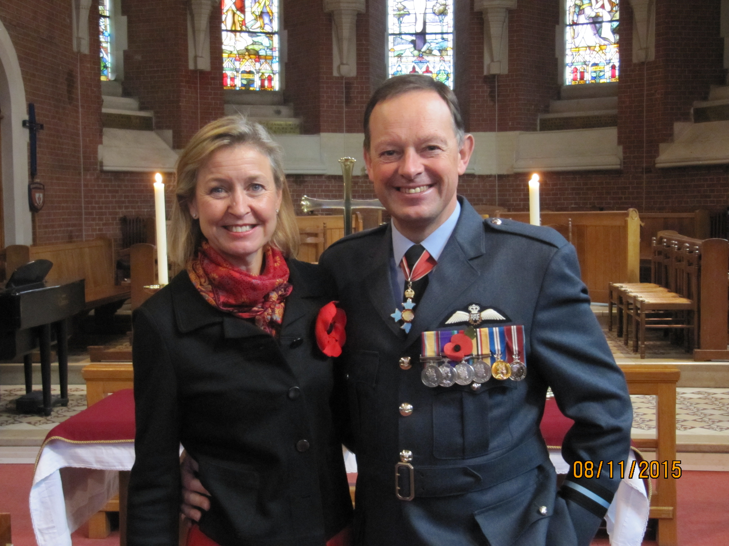
John and Penny

Having served on Squadrons and Stations with long and illustrious histories, I have always recognised the importance of creating a link between today’s modern Air Force and that of our predecessors. And for that reason I am a firm supporter of the work done by both the Royal Air Forces Association and the Royal Air Force Benevolent Fund. Here I also see the need for our larger associations to look to support those organisations with a specific link to Airman in Europe such as the Comet Line. My own experience of meeting some of the operatives, who supported both the Royal Air Force Escape and Evaders and aircrew flying for the Special Operations Executive, has been quite inspiring. With the numbers of veterans decreasing, as your President, one of my goals is to ensure that Remembrance of sacrifice is honoured; not only on high days but also in the communes of Belgium – and here too I have promised my support to the British Embassy who often hears of initiatives direct from locally formed groups.

Another goal is to ensure that we continue to build on the links with our Belgian Air Force colleagues and their veterans. The close ties forged during the Second World War between our two respective Air Forces is something that I know our modern day Chiefs of Air Staff / Components value. You only have to listen to the music of the Belgian Air Force Band and read through the Squadron F540s to realise the extent of the integration of our Services during those dark days.
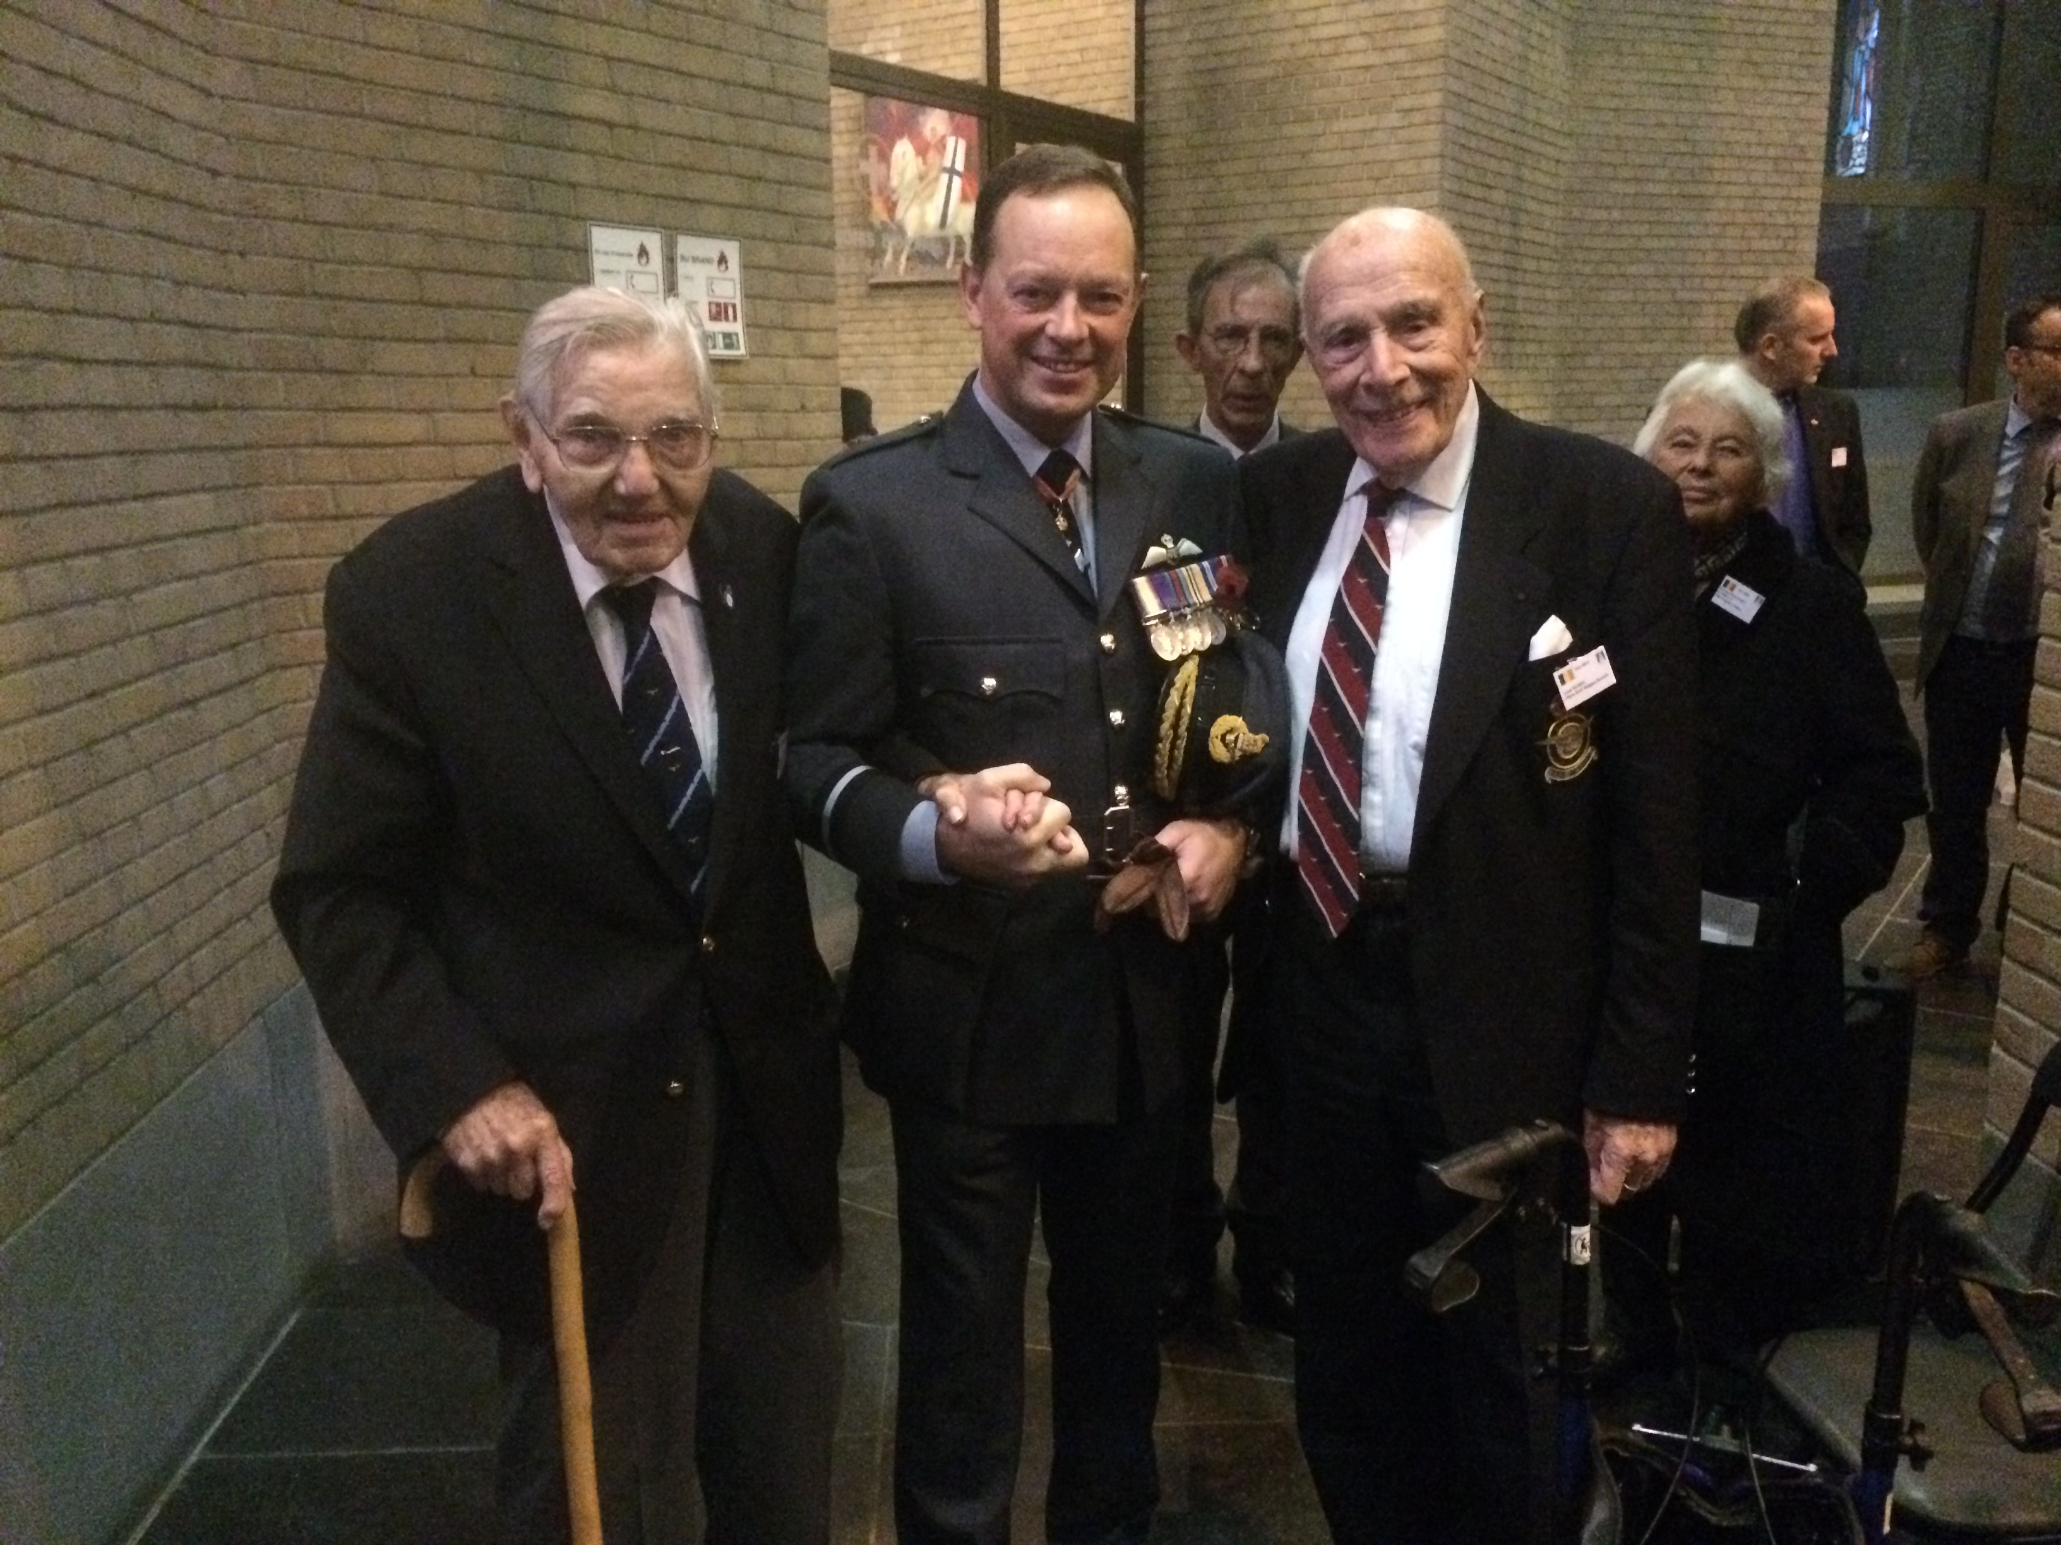
A meet up between aviators of different generations Mr Frost (on the left) benefited from the services of the Comet Line and Belgium’s very own Leon Rubin – Spitfire pilot and native of Grindelwald – hold a myriad of stories between them.
My last hope is to reach out to some of the younger groups in Brussels and with the help of Brigitte Horton – a stalwart of our Committee – create a close link with the Royal Air Force Air Training Corps by fostering a twinning between a Squadron and our Brussels Branch.

In closing, I’d like to thank all on the Committee of the Royal Air Force Association in Brussels for the warmth of their welcome and to wish you all happiness and good luck for 2017.

Yours aye
John Maas

